**Assignment 1**

**j = 1, i = 0**

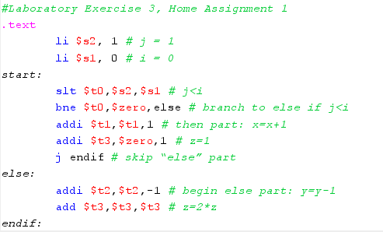



$t0 = 0x00000000





$t1 = 0x00000001



$s3 = 0x00000001

**j = 0, i = 1**

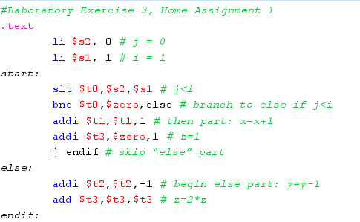



$t0 = 0x00000001





$t2 = 0xffffffff



$t3 = 0x00000000

**Assignment 2**

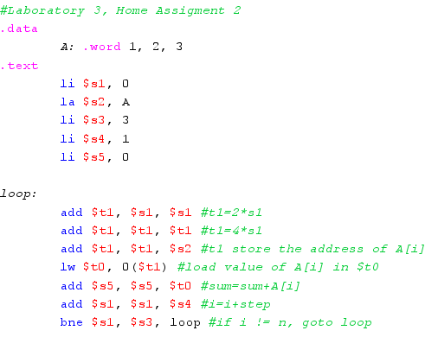

$s1 = 0x00000000

$s2 = 0x10010000

$s3 = 0x00000003

$s4 = 0x00000001

$s5 = 0x00000000

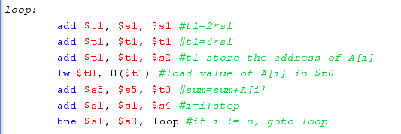



$t1 = 0x00000000



$t1 = 0x00000000



$t1 = 0x10010000



$t0 = 0x00000001



$s5 = 0x00000001



$s1 = 0x00000001

(1 != 3 => loop)

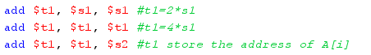

$t1 = 0x00000002 => 0x00000004 => 0x10010004



$t0 = 0x00000002



$s5 = 0x00000003

(2 != 3 => loop)



$t1 = 0x00000004 => 0x00000008 => 0x10010008



$t0 = 0x00000003



$s5 = 0x00000006

(3 == 3)

**Assignment 3**

**# test = 0**

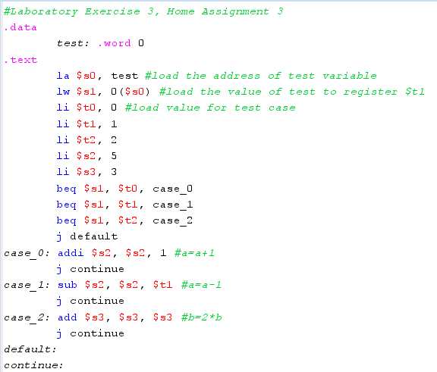

$s0 = 0x10010000

$s1 = 0x00000000 (test)

$t0 = 0x00000000 (case_0)

$t1 = 0x00000001 (case_1)

$t2 = 0x00000002 (case_2)

$s2 = 0x00000005 (a)

$s3 = 0x00000003 (b)

(0 == 0 => case_0)



$s2 = 0x00000006

=> continue

**# test = 1**

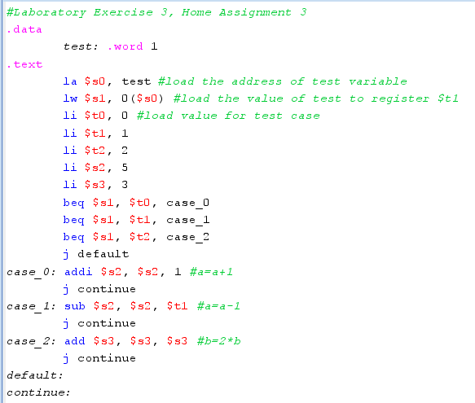

$s0 = 0x10010000

$s1 = 0x00000000 (test)

$t0 = 0x00000000 (case_0)

$t1 = 0x00000001 (case_1)

$t2 = 0x00000002 (case_2)

$s2 = 0x00000005 (a)

$s3 = 0x00000003 (b)

 (1 != 0)

(1 == 1 => case_1)



$s2 = 0x00000004

=> continue

**# test = 2**

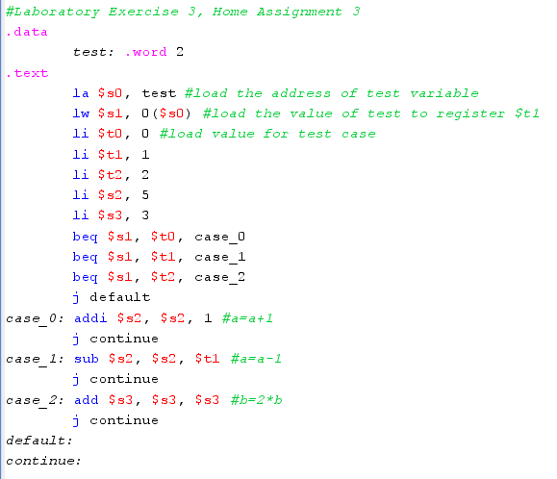

$s0 = 0x10010000

$s1 = 0x00000000 (test)

$t0 = 0x00000000 (case_0)

$t1 = 0x00000001 (case_1)

$t2 = 0x00000002 (case_2)

$s2 = 0x00000005 (a)

$s3 = 0x00000003 (b)

(2 != 0)

(2 != 1)

(2 == 2 => case_2)



$s3 = 0x00000006

=> continue

**# test = 3**

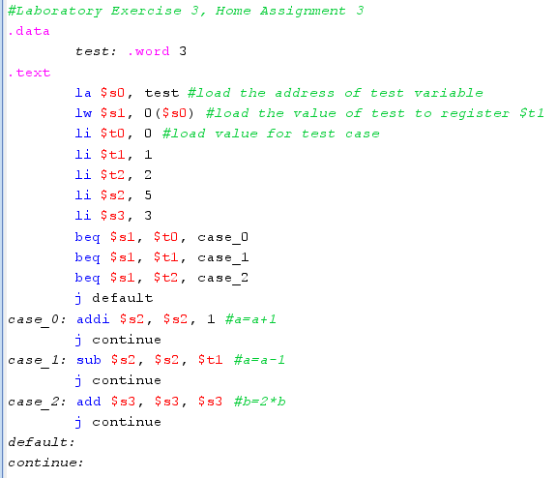

$s0 = 0x10010000

$s1 = 0x00000000 (test)

$t0 = 0x00000000 (case_0)

$t1 = 0x00000001 (case_1)

$t2 = 0x00000002 (case_2)

$s2 = 0x00000005 (a)

$s3 = 0x00000003 (b)

(3 != 0)

(3 != 1)

(3 != 2)



=> default

**Assignment 4**

**a) i < j**

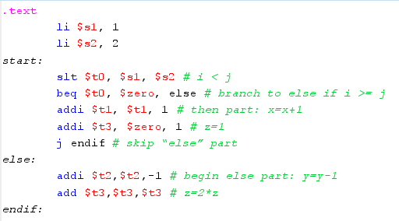

**b) i >= j**

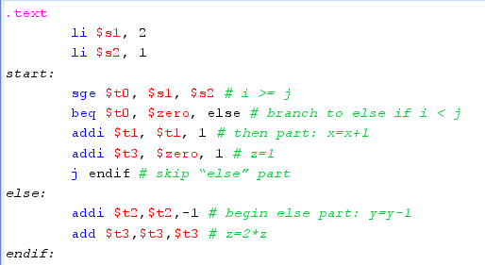

**c) i + j <= 0**

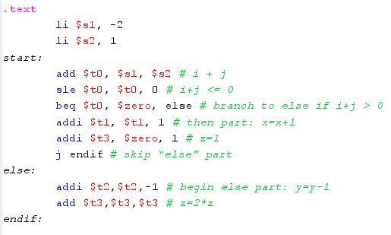

**d) i + j > m + n**

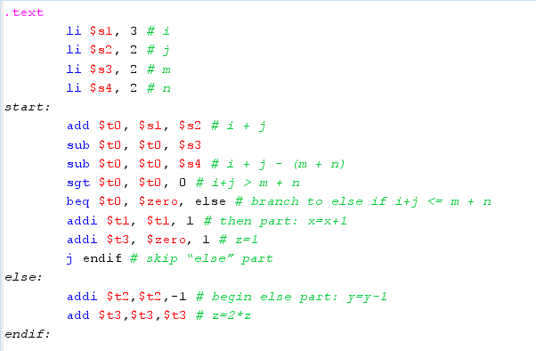

**Assignment 5**

**a) i < n**

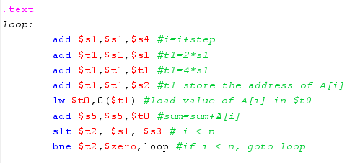

**b) i <= n**

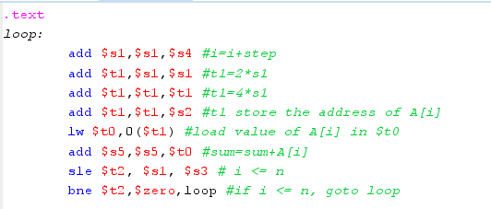

**c) sum >= 0**

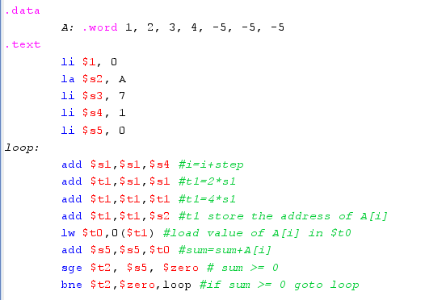

**d) A[i] == 0**

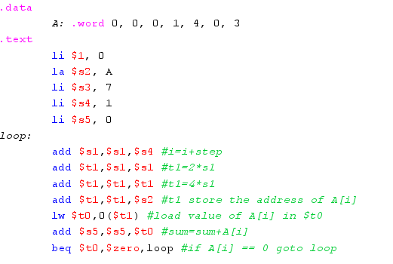

**Assignment 6**

